Technical Resume Writing: A Guide

1
Introduction

Your resume is a career narrative, it is your chance to tell a story about what you have achieved in the past and your goals for the future. It should reflect who you are as a candidate, including your skills, experience and potential. The ultimate purpose of your resume is to get you a job interview. However, a great resume can help you become a front runner in the interviewer’s mind before you even meet.

While many candidates have excellent skills and considerable professional experience, when it comes to writing their resume, they are stumped by the task of choosing a structure, understanding what should be included or left out, and properly detailing their experience.

The aim of this guide is to help you create a resume that will not only land you a job interview, but also help you land a job offer.

2
Table of Contents

INTRODUCTION 2

1. CONTENT 4

PERSONAL DETAILS 4

THE OBJECTIVE 4

WORK EXPERIENCE AND DESCRIBING JOB DUTIES 5

CORE COMPETENCIES 6

VOLUNTEER WORK 6

EDUCATION 7

MEMBERSHIPS AND AFFILIATIONS 7

REFERENCES 8

TAILORING YOUR RESUME 8

ETHICAL CONSIDERATIONS 8

2: STRUCTURE 9

WHY LAYOUT MATTERS 9

CHRONOLOGICAL LAYOUT 9

FUNCTIONAL LAYOUT 9

CHRONOLOGICAL LAYOUT EXAMPLE 10

FUNCTIONAL LAYOUT EXAMPLE 12

WHICH RESUME TYPE SHOULD I USE? 13

3
1. Content
Before you dive into writing your resume gather all the information you need to faithfully detail your employment history and job duties:

- Start by collecting the company name, dates of employment and job title for each position held.
- Jot down any skills you have that may be relevant to your search, such as software programs used at different jobs, coding skills, specialized training and spoken languages.
- Gather your education history including degrees acquired, dates of attendance, any honors or awards, and certifications.
- Consider who can act as a reference for you from each job.
- Identify any periods when you were not employed.

After you have gathered all the necessary information it is time to prepare the first draft of your resume!

Personal Details
Regardless of how you choose to structure the rest of your resume, it should begin with a header consisting of your full name, location and contact information.

Veronica Mars
Neptune, CA | (000) 000-0000 | vmarshmellow007@gmail.com | github.com/vmars | www.veronicamars.com

As job boards have moved online, it is not advisable to include your address; a zip code or city suburb will suffice, along with your phone number and email. Employers only need to be able to get in contact with you and understand your general location.

Your resume should never expressly include information such as race, gender, age, marital status, physical appearance, health information or any other such personal details.

The Objective
Because most resume templates include a space for an objective, many candidates feel they need to include one at the beginning of their resume. However, most objectives are generic and fail to increase your appeal to hiring professionals. If you choose to include one, avoid vague phrases, such as those in the example below, that say little to nothing about you as a candidate or your skill set.

‘Seeking engineer position that best utilizes my skills in a dynamic corporation where I can grow and contribute to a team.’

Remember that space on your resume is limited so you must use it deliberately, and a lackluster objective does nothing to differentiate you from the next candidate. Only include an objective if it shows off your skills, and gives the person reviewing your resume an idea of how you would fit into their team. In the example below, note the underlined words specifically highlight the skills, experience and job search goal of the applicant.

‘Bilingual full-stack .NET Developer with over 5 years of experience working in a large development team for a multinational telecommunications company, seeks lead developer position in a smaller corporate or startup environment.’

Only include an objective if you have a specific job goal in mind. Do not include one if you are more interested in seeing what types of positions are available. It is better to have no objective than something vague or dull; you do not want a hiring committee to associate you with either of those adjectives!

Core Competencies
Core Competencies include a wide range of technology skills including languages, tools, frameworks, databases, IDE’s, design or architecture patterns, cloud platforms, operating systems, reporting applications, and development methodologies. Please note, this list is not dispositive, and it is important to tailor your Core Competencies section to your individual skill set as well as the sought-after position.

We will look at three common formats for outlining Core Competencies:
- Bullet Point Format
- Table Format
- Position Specific Format

Bullet Point Format:
The Bullet Point Format is the most commonly used format as it is easily tailored to varied skill sets, and offers a straightforward way for you to communicate your skills to a potential employer.

Start by listing your core competencies such as coding languages, frameworks, databases, etc. Then, as illustrated in the example below, simply list the applicable technology skills associated with each core competency.

Technical Skills and Core Competencies:
- Languages: JavaScript (node, vue, dimple, react, express), SQL, Typescript, HTML5, CSS3, C#, jQuery
- Frameworks: Entity, Bootstrap
- IDE’s: MS Visual Studio, Sublime, NetBeans
- Databases: MS SQL Server, mongoDB, MySQL
- Cloud Platforms: AWS, Azure
- Bug Tracking: JIRA
- Version Control: Git, Team Foundation System
- Methodologies: Test Driven Development (TDD), Agile, Waterfall, Service Oriented Architecture (SOA)
- Other: Splunk, Slack, Confluence

Table Format:
The Table Format provides the same information as the Bullet Point Format but arranged into a table. As illustrated in the following example, each core competency has its own box in; note the use of color to ensure each box is easily differentiated from the surrounding boxes.

The Table Format should be used for especially large and varied skill sets, where a Bullet Point Format would take up one-half or more pages on the resume. As you can see, the example candidate in figure 1.2.2 has many more skills and core competencies to list than in figure 1.2.1, and so the table format provides an elegant and easy to skim solution.

Technical Skills and Core Competencies:
Languages | Frameworks
JavaScript (React, Vue, Node, Express), TypeScript, C#, PHP, Java, SQL, NoSQL, ASP.NET, Go | .NET MVC, Bootstrap, Spring MVC, .NET Core, Selenium, Apache Spark
Databases | Mobile Development
MS SQL Server, MySQL, PostgreSQL | Swift, Objective-C, Kotlin, Xamarin, Gradle,
Version Control and Bug Tracking | Cloud and DevOps
Git, Bitbucket, Bugzilla, JIRA, Team Foundation System | Azure, AWS, RedShift, Heroku, S3, Jenkins, Kubernetes, Docker, Terraform
Methodologies | Other
Agile, Waterfall, Behavior Driven Development (BDD), Test Driven Development (TDD), SOLID, Service Oriented Architecture (SOA), Scrum | Splunk, Tableau, Confluence, Slack

Position Specific Format:
A Position Specific Format is very different from the Bullet Point and Table Based Formats. It is a good format choice if you’ve used several different technology-stacks across roles, or if you have quite a lot of experience that is no longer current or relevant for your job search. Examples of when you may choose to use this format include, starting in front-end development and moving into full-stack or back-end development, moving from a networking role into DevOps, or moving out of hands on development and into managerial or architectural positions. Using the Position Specific Format allows you to showcase the evolution of your skills over time as well as your most current repertoire.

When utilizing the Position Specific Format you will not need to include a separate Core Competencies section in your resume, instead these will be integrated into the Work Experience section. After providing the company name, position title, dates of employment, and responsibilities, list out your technology skills in an attached paragraph as illustrated in figure [].

Experience:
ABC Bank January 2014 – August 2017
Senior Mobile Developer
- Adding new features to the existing native java TSB Mobile banking application including switching the code base to use Gradle, structure changes to use Dagger Dependency injection and converting all unit tests to Junit4 and Roboelectric.
- Leading team of 6 developers as Scrum Master and Technical Lead
Programming Tools: Swift, Objective-C, Java, Kotlin, Android, Android Studio, Jenkins, GitHub, JavaScript, HTML, CSS, JSON, Swagger, Agile Development

Work Experience and Describing Job Duties
Each position should be listed in reverse chronological order, include the name of the company, dates of employment and position title. Your resume should highlight the skills and daily tasks of each position, as well as your major achievements. Each position should contain between 5-8 bullet points, with each bullet point containing 1-2 sentences detailing job duties along with examples.

Formatting a Strong Bullet Point

Action Verb + Description of Activity + Scope/Processes + Tools, Languages and Frameworks

‘Developing and maintaining a workflow portfolio management web application using domain driven and first-test development in C#, ASP.NET web API, ASP.NET MVC, nunit, moq, SQL-server, JavaScript, JSON, HTML, Bootstrap, CSS and AJAX.’

Always lead with a strong action verb either in the ‘-ing’ form, or in the past tense, commonly ‘-ed’ form. Either is fine, but make sure you are consistent!

Sample Action Verbs
Delegating | Maintaining | Budgeting | Scheduling
Solving | Implementing | Improving | Researching
Managing | Creating | Generating | Distributing
Designing | Editing | Building | Investigating
Liaising | Overseeing | Arranging | Summarizing
Advising | Developing | Analyzing | Assisting
Preparing | Assessing | Organizing | Customizing
Overhauling | Identifying | Conducting | Testing
Initiating | Architecting | Leading | Querying
Participating | Resolving | Supporting | Delivering
Analyzing | Visualizing | Integrating | Customizing
Improving | Updating | Bundling | Simplifying

Similar job duties should be grouped together under each bullet point such as project management or requirements gathering, specific projects, day-to-day maintenance or management duties.

Experience:
Example Company January 2018 – Present
Lead Front-End Engineer
- Integrating mode.js microservices with external API’s, as well as leveraging node.js microservices using react.js in order to increase the supportability of the mobile platform.
- Building an analytics and data visualization web portal that centralized SQL-server data sets and rendered them using JavaScript libraries, as well as integrating with Splunk logging infrastructure.
- Overhauling customer facing pages in the form of wizards to attract customer trial sign ups using vue.js achieving a user increase of 35% over 4 weeks.
- Liaising with cross functional teams to create applications solutions including assisting with planning and architectural design, development, resolution of technical issues and application rationalization.
- Conducting training sessions on Test Driven Development (TDD) and Behavior Driven Development (BDD) in JavaScript for Front-end and Back-end with frameworks including jest, jasmine, mocha and chai.

Key Terms

Major online job boards including LinkedIn, Indeed, CareerBuilder and ZipRecruiter all have search functions, whereby employers can locate candidates with specific skills using Key Terms. To give yourself the greatest chance of appearing in searches, make sure you are including Key Terms in your description as well.
These can be: any specific technology skills such as languages ‘C#.NET, VueJS, Java, Python’; a development structure or framework ‘SOLID Principles’, ‘Agile’, ‘Entity Framework’ or ‘XML’; or a specific process ‘Migrating from on-premises server to AWS’, ‘Built a kiosk PHP MVC web app for even registration’ or ‘Integrating node.js microservices with external RESTful API’s’.
The aim of including each of these terms or skills is to make your resume more searchable for modern recruiters.

Return On Investment (ROI)

Try to include at least one Return On Investment (ROI) statement for each position. An ROI statement should highlight an achievement or value added while you worked in each role. Examples of ROI’s can include saving the company time or money, finishing a project at or before deadline, architecting a new workflow, receiving an award or consistently hitting goals set by management. Try to quantify your contributions using dollar amounts, percentages, number of users, hours saved and other similar information, to make your achievements more concrete and credible.

‘Advancing the adoption of new technologies, tool and processes to streamline delivery capabilities and ensure delivery timelines are being met.’

‘Overhauling customer facing pages using vue.js in the form of wizards, to attract customer trial sign ups achieving a user increase of 35% over 4 weeks.’

There are myriad forms that an ROI can take, so take your time to carefully think over what you are proud to have achieved in each role and include it on your resume.

Education
Next list your education in reverse chronological order. Include completed certifications with your most recent degree first. List the awarding institution, the year you graduated, and your major and any minors. Also include any honors or inclusion on the dean’s list. Only list your GPA if it is at least a 3.5 or above.

Education:
Carnegie Mellon, Tepper School of Business 2017
Master of Business Administration (MBA)

University of California, Berkley 2012
Bachelor’s Degree in Computer Science

If you have an associate degree or above, do not include your high school diploma.

Certifications and Affiliations
Provide brief details of memberships and affiliations including certifications, continuing education, board or professional society memberships and the like in this section.

Certifications and Memberships:
Microsoft Certified Solutions Associate – SQL Server 2014 2017

Scrum Alliance Certified Scrum Professional 2016

Volunteer Work

Volunteer work needs a separate subheading briefly listing the organization, role, outstanding achievements and dates of service. No more than 2 bullet points outlining your role in each volunteer position are needed.

Volunteer Work:
Code.org 2015 - Present
Instructor
- Hosting various ‘One Hour of Code’, one-hour introductory courses designed to demystify computer science and show that anybody can learn the basics, at local libraries, primary and middle schools.

Only include long running volunteer positions, do not clog this section with individual fundraisers like 5k’s or bake sales.

References
References may be from previous employers, teachers (if you are seeking your first job) or a volunteer agency’s management. Never assume someone will act as a reference; always obtain consent before listing anyone as a referee. Furthermore, as a courtesy do not include their information on your resume. Instead type out a separate document with the name, title, phone number and email of each person providing a reference. Only give this document to a potential employer once you are in serious consideration for a position.

Johnny Appleseed - References:

Oprah Winfrey

Supervisor, the Oprah Winfrey Show

(305) 111-1111

Ellen Degeneres

Supervisor, the Ellen Degeneres Show

(305) 111-1112

Judge Judy

Manager, the Judge Judy Show

(305) 111-1113

Tailoring Your Resume
Uniquely tailor your resume to highlight that your skills meet a hiring company’s requirements. This makes it easier for potential employer to understand how you fit their needs. Do not re-write your resume for each-and-every position, instead save time by creating a Master Resume. A Master Resume is a complete compilation of all your skills and experience into one master document with every job, skill, certification and degree properly detailed according to the guidelines listed above. The, to tailor your resume to a specific job posting, create a new resume by picking out the sections that apply to the specific job, skill or achievement, from the Master Resume.

Note: During the interview process you should bring copies of both your Master Resume and your Tailored Resume in case you need to refer to some experience or skill set you have not included in the tailored version. An interviewer may be interested in experience that you had not anticipated, and it is always best to be prepared.

Ethical Considerations
Finally, you should always be truthful throughout the recruiting process. Embellishing your skill set, falsifying your employment history and otherwise including incorrect or misleading information in your resume can significantly damage your reputation, and even cause a job offer to be rescinded.

8

2: Structure

Why Layout Matters

Along with content, structure dictates the first thing potential employers will learn about you, which gives you the opportunity to tailor your first impression. Research has shown if you initially make a bad impression, it takes seven additional good interactions to make up for it, so it is critical not to disadvantage yourself from the beginning.

There are two main resume structures to choose from: the Functional layout and the Chronological layout. Choose the resume style that best suits the type of job you seek, your unique skill set, and experience. Of course, these are general guidelines, and in most cases, you will need to make individual tweaks.

Note: Many resume writing guides still stress the importance of a keeping your resume to one page in length, but it is far more important to correctly detail your skills and experience. Using tiny margins and ridiculous formatting for the sake of keeping your resume to one page, causes more harm than good.

Functional Layout
Resumes in the technology field often use a skills-based Functional Layout which is arranged around your language, tooling and other programming skills. While this layout allows for much greater variation in style than a Chronological Layout, there are also many ways it can go wrong.

The most important consideration for this skills-based layout is whether your resume has good flow. Flow occurs when there is a clear and logical progression of ideas moving down the page and, a resume with good flow is easy to read and understand. For English speakers, the eye naturally wants to travel from left to right and down the page. Format your resume to accommodate this inclination by laying information out left to right, in horizontal sections moving down the page.

In this guide, the Functional Layout is used in conjunction with either the Bullet Point Format or Table Format (outlined in section Core Competencies).

A Functional Layout should include the following factors:
- A header with the candidate name, phone number, email and city or zip code.

- A Core Competencies section grouped by areas of expertise.

- An Experience section briefly outlining each position in reverse chronological order, major projects and an ROI.

- An Education section, listing each degree or certification obtained in reverse chronological order.
- A Certifications and Affiliations section outlining any certificates obtained or professional memberships.

Chronological Layout
The Chronological Layout is used when Core Competencies are provided in the Position Specific Format or Traditional List Format.

The Chronological Layout is the traditional and most common layout for a resume. It is based around experience and is arranged in reverse chronological order with the most recent position listed first and the oldest position listed last.

A Chronological layout should include the following factors:

- A header with the candidate name, phone number, email and location.

- A section for Work Experience with each position listed in reverse chronological order and, if you are using the Position Specific Format for Core Competencies, list the core competencies for each position (see example on page x under section heading y).

- An Education section, listing each degree or certification obtained in reverse chronological order. The

- A Memberships and Affiliations section listing any pertinent organizations or qualifications separate from education and experience.

- A Skills section outlining any technology, language or other similar skills if you are using the Traditional List for Core Competencies.

9
Chronological Layout Example
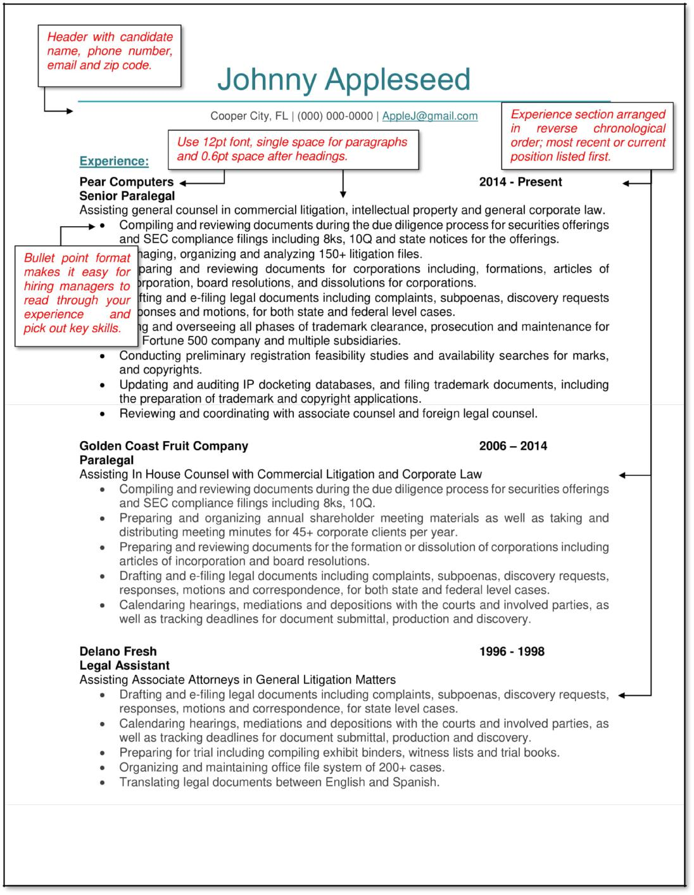

10
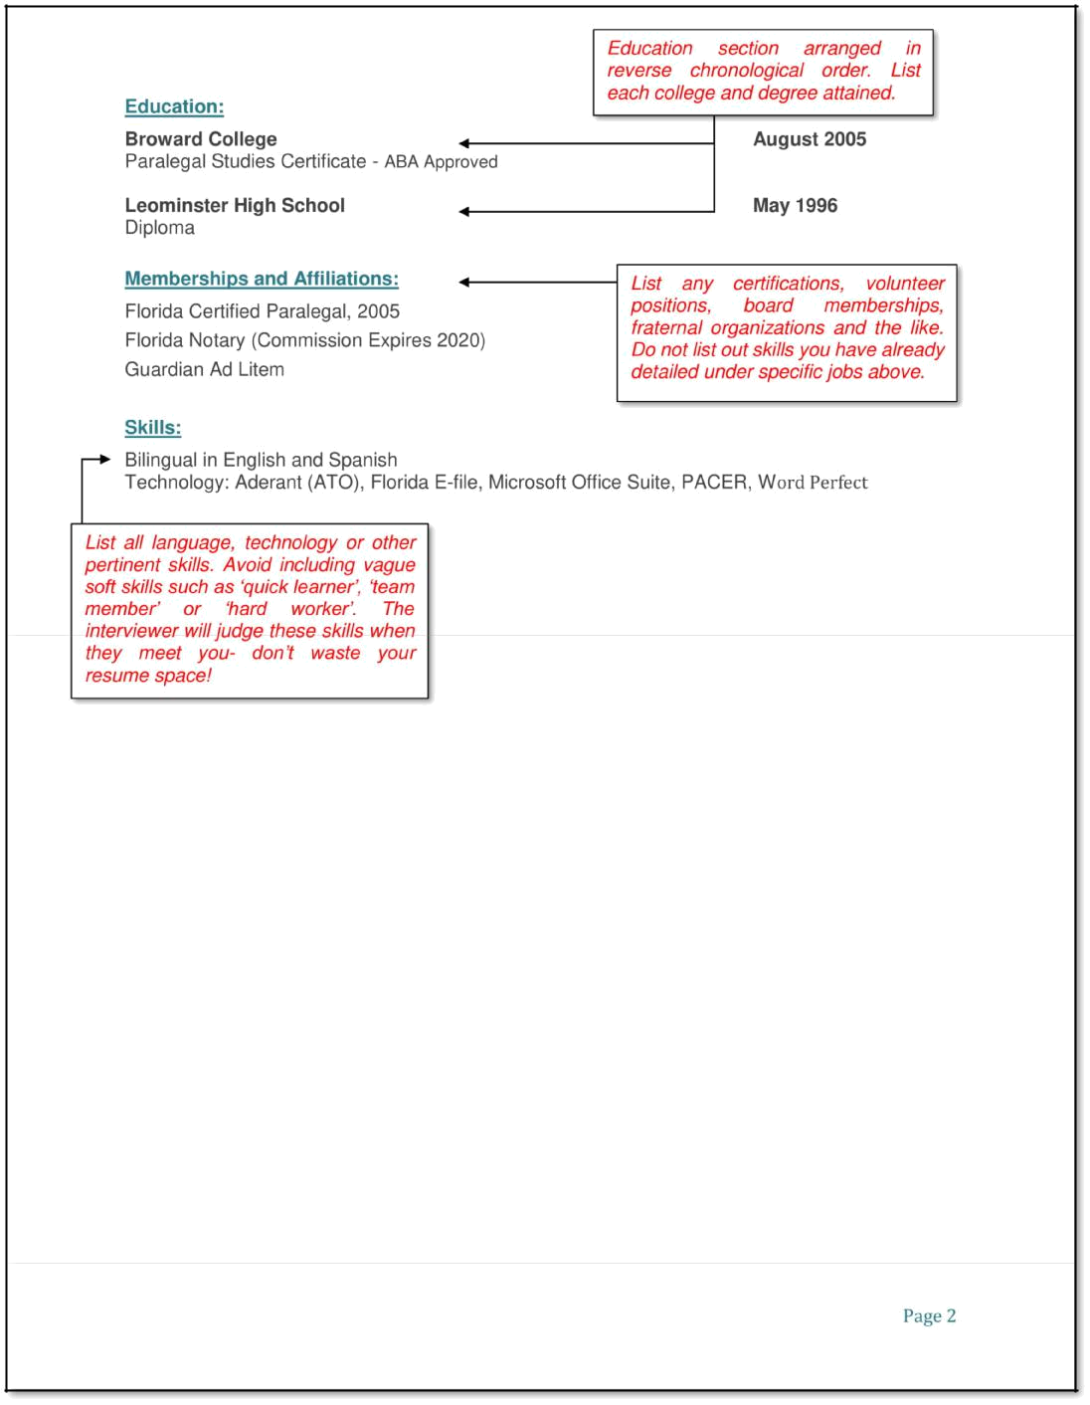

11
Functional Layout Example
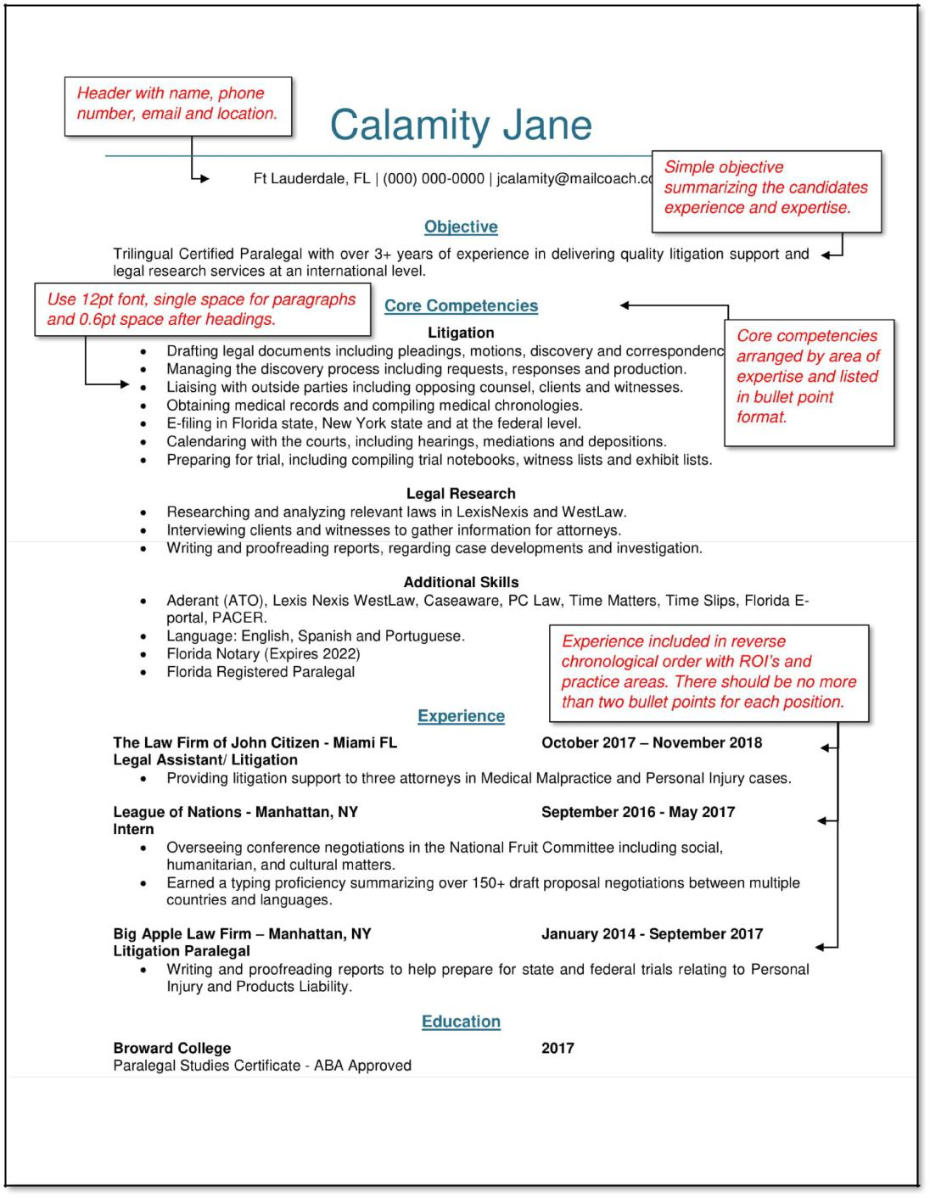

12
Which resume structure should I use?

Most candidates should use a Chronological layout, even if you have gaps in your resume or are starting in a new field. Employers will want to know your work history no matter how you initially present yourself. This is particularly pertinent to the legal industry, and even more so for litigation positions, because of conflicts of interest considerations.

Functional Layout:

Advantages:

- More room to be creative and stand out from other applicants.

- Could help minimize work or experience gaps.

Disadvantages:

- A much higher risk of looking disorganized or being poorly executed.

- Does not show how or where you gained certain skills.

- More difficulty being parsed through ATS.

Chronological Layout:

Advantages:

- Familiar format for hiring professionals and therefore easily understandable.

- Applicant Tracking Systems (ATS) can easily parse this format.

- Emphasizes stable work history and linear career development.

Disadvantages:

- While this format is familiar for recruiters and interviewers, it won’t help you stand out from the crowd.

- Employment gaps or a lack of experience are more noticeable.

Clearly, there are more risks involved in using a Functional layout and the majority of job seekers should use a Chronological layout. A Functional resume is best used when you are making a career switch, just entering the workforce, or have been working on a freelance or project base.

13

